ROVER CODE

Step 1
Extract to your drive.

Step 2
Navigate to \WIFIROVER\TCPIP\Demo App and double click WiFiRover.mcw

This should load MPLAB

Then all the interesting bits (that you will change) are in rovercode.c.

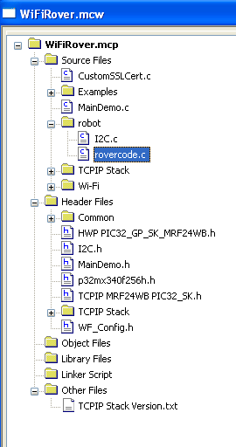
Don't change anything else unless you are sure!

The code takes in TCP messages and responds with TCP messages.

void processcommand(void) // the main routine which processes commands
There is code for all the given commands (SEE 2013 DATATYPES.DOCX)

In order to respond use the following procedures
POSTTCPhead(LEN,ID); // prepares a response of TAG ID and length LEN
POSTTCPchar(c); // adds a char to the TCP packet. Packet gets sent when processcommand() finishes.
There is a routine
void InitializeBoard(void)
which sets up ports etc of the board. You might need to change this if you change what is attached to the board.

There are a number of Interrupt routines which either cope with timing or devices.
void __attribute((interrupt(ipl3), vector(_ADC_VECTOR), nomips16)) _ADCInterrupt(void)
This reads the two ADCs channels used for the Line following. The routine also decodes the IR bit stream from the crashed rocket (uses the fact that it is called at a regular rate).

void __attribute((interrupt(ipl4), vector(_INPUT_CAPTURE_1_VECTOR), nomips16)) _IC1Interrupt(void)
Records movement of track.

void __attribute((interrupt(ipl4), vector(_INPUT_CAPTURE_3_VECTOR), nomips16)) _IC3Interrupt(void)
Records movement of other track.

In other c files (to make sure you don't use them)!
in TICK.C
void __attribute((interrupt(ipl2), vector(_TIMER_1_VECTOR), nomips16)) _T1Interrupt(void)
Timer 1 is used by the system (WIFI etc) to measure time
in WF_Eint.c
void __attribute((interrupt(ipl3), vector(_CHANGE_NOTICE_VECTOR), nomips16)) _WFInterrupt(void)
The change_notice interrupt is used as part of the handler for the WIFI module

OTHER PERIPHERALS in PIC that are used
Input captures 1 to 4.
SPI PORT 1
I2C port 2
Timer 2
Timer 3
Output compares 2 to 5
Examples of cases in processcommand

number after case matches ID number
case 2:if (commandlen==1) //Set LEDs
{ // OK we have 1 byte of info
// look bits in data using AND and set the port pin.
if (nextcommand[1] & 2) LED1_IO=0; else LED1_IO=1;
if (nextcommand[1] & 1) LED0_IO=0; else LED0_IO=1;
POSTTCPhead(0,2);// send a null ACK with ID 2
}
break;
case 3: // get internal counter
POSTTCPhead(2,3); // set up return packet to contain 2 bytes with an ID code of 3
POSTTCPchar(REQCOUNT & 0xff); // send the lower 8 bits of count
POSTTCPchar((REQCOUNT>>8) & 0xff); // send the upper 8 bits of count
REQCOUNT++; // increment the count
break;

